STUDENT PERFORMANCE EDUCATIONAL EQUITY AND INSIGHTS

NAME : VEDHAVARSHINI PRIYA E.A.S

ROLL NO : 26BSC107

SUBJECT : PYHTON FOR DATA ANALYSIS

CLASS : B.SC COMPUTER SCIENCE

GOOGLE COLAB LINK : https://colab.research.google.com/drive/1S3EZZlTIW8b4YWNQ4T23RBRSpvLT9Ra8?usp=sharing

1 . INTRODUCTION

This report examines student performance in Math, Reading, and Writing and investigates whether outcomes differ by parental education level, lunch type, and completion of a test-preparation course. It also explores relationships among the three subjects to identify whether strengths or weaknesses tend to appear across multiple academic areas.

2 . ANALYSIS OF PARENTAL EDUCATION

The grouped bar chart compares average Math, Reading, and Writing scores for each parental education category. In typical versions of this dataset, average scores tend to rise as parental education increases, with children of parents holding master’s or bachelor’s degrees generally scoring higher than children whose parents attended only high school or some high school.
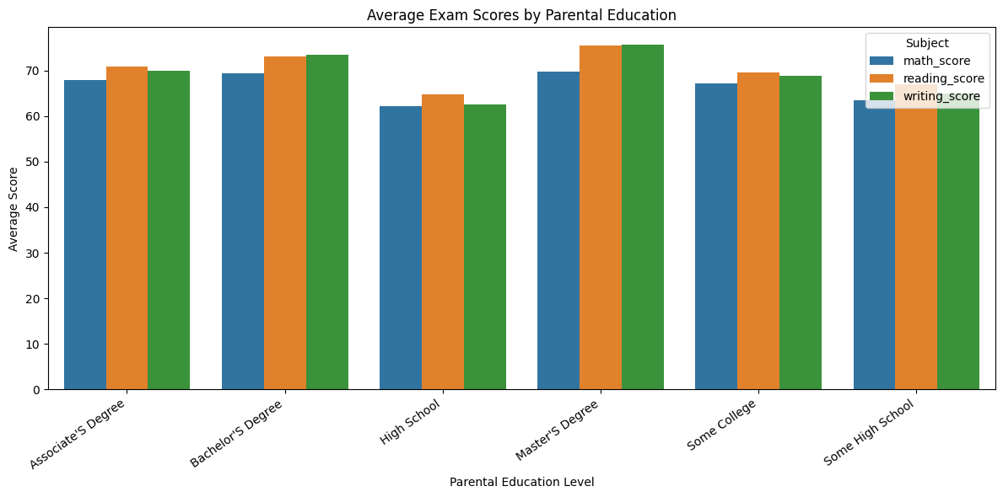

3. ANALYSIS OF LUNCH TYPE

The lunch variable is commonly used as a proxy for socioeconomic status: free/reduced lunch generally indicates greater financial need, while standard lunch indicates less need. The chart compares average subject scores between these groups.

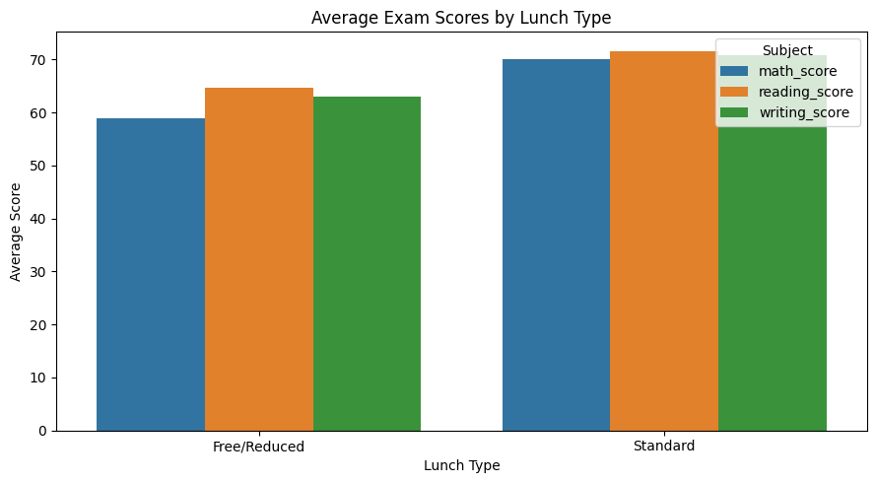

4. TEST PREPARATION ANALYSIS

Box plots show the distribution of scores for students who completed versus did not complete the test-preparation course. They reveal the median, interquartile range, overall spread, and potential outliers.
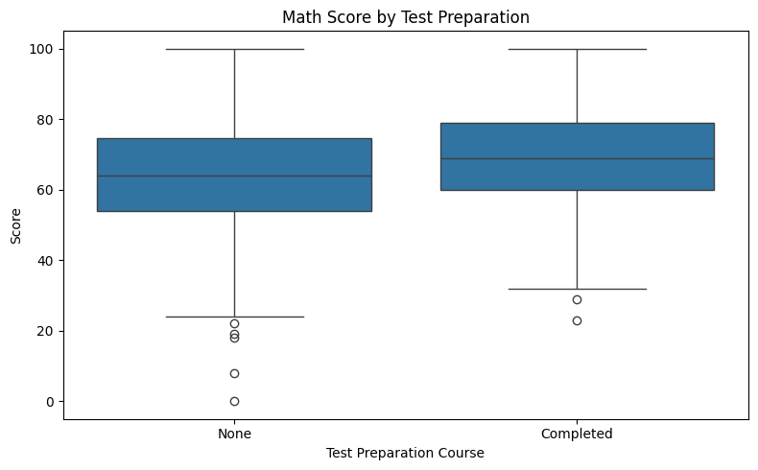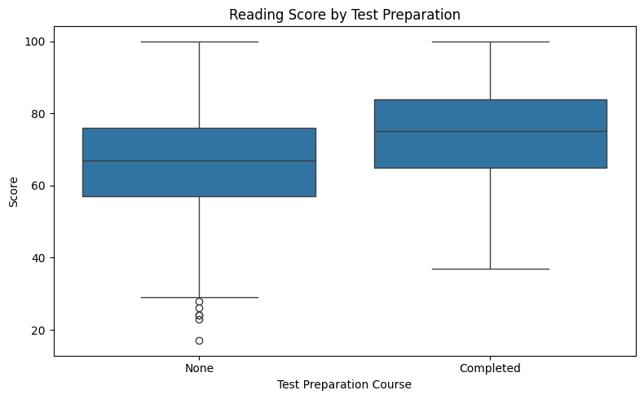
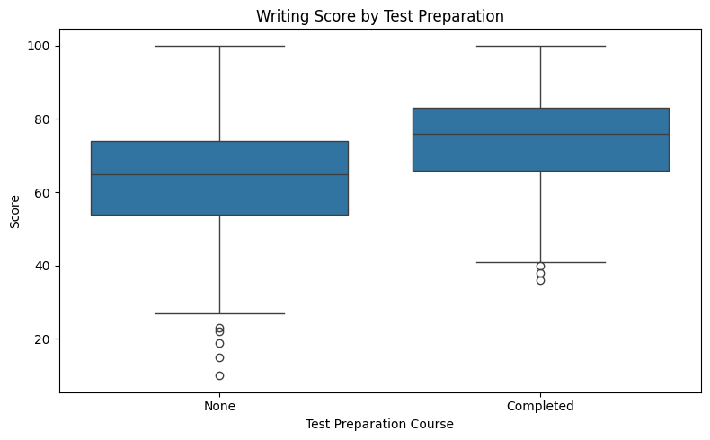

5. SUBJECT CORREALTION ANALYSIS
Scatter plots show pairwise relationships among Math, Reading, and Writing scores, while the heatmap summarizes the correlation coefficients.

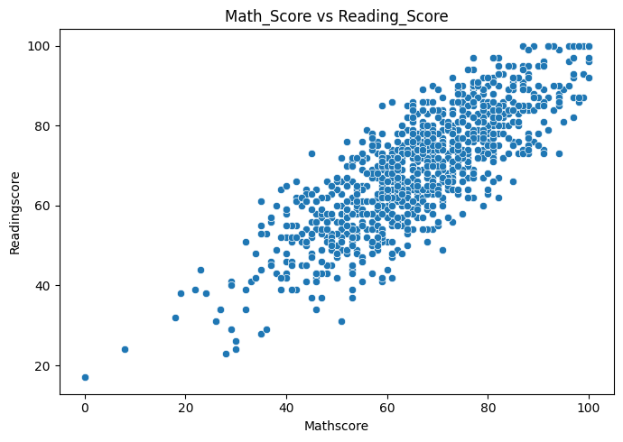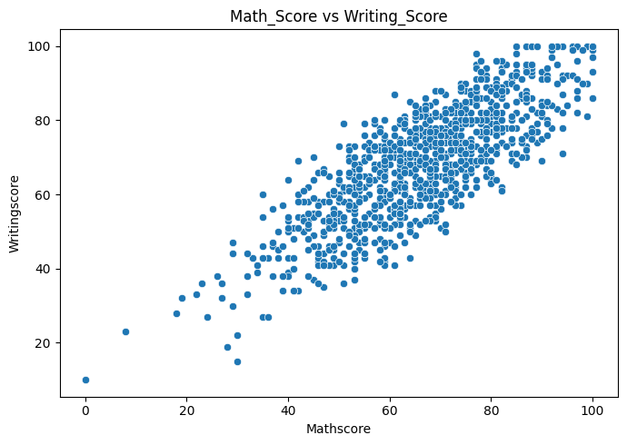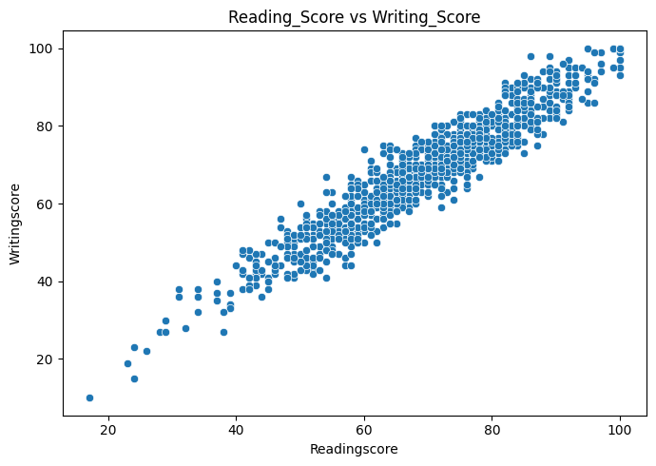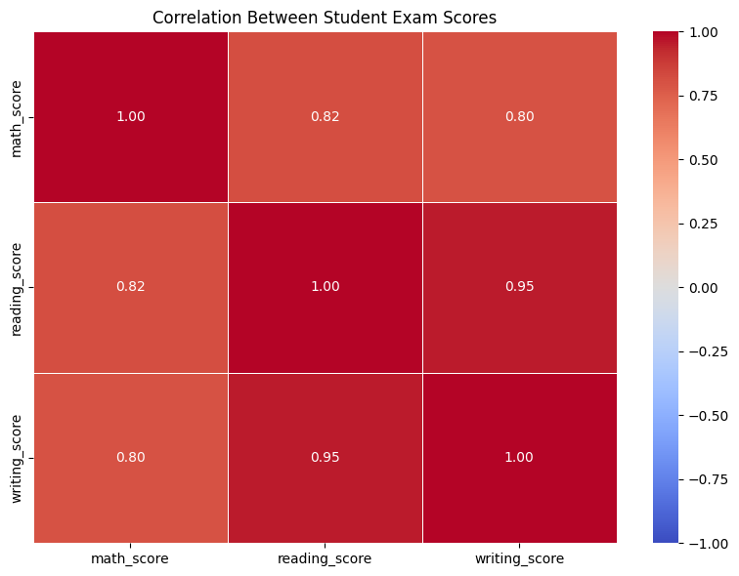

6. EDUCATIONAL EQUITY RECOMMENDATIONS

- • Provide targeted academic support: Offer additional instruction in subjects where average scores or medians are lower, particularly for groups showing persistent gaps.
- • Expand access to test preparation: Make preparation courses free or low-cost, schedule them outside restrictive hours, and provide online, in-person, and small-group options.
- • Support students facing socioeconomic barriers: Pair academic help with practical supports such as tutoring, mentoring, device and internet access, attendance support, and family communication.
- • Use subject-level interventions: If Reading and Writing are strongly correlated but Math is weaker, provide math-specific support rather than assuming a single literacy intervention will solve all gaps.
- • Monitor outcomes by group: Track scores by parental education, lunch type, test-preparation status, gender, race/ethnicity, and school where appropriate, while protecting student privacy.
- • Evaluate before scaling policy: Pilot interventions, compare pre- and post-intervention outcomes, use comparison groups where feasible, and examine whether benefits are sustained over time.

7. LIMITATIONS

Group differences and correlations do not establish causation. For example, a relationship between lunch type and scores may reflect socioeconomic conditions, school funding, family circumstances, or other unmeasured factors rather than lunch status itself.

The analysis also may not account for factors such as teaching quality, class size, attendance, English-language proficiency, disability status, prior achievement, family stability, or access to learning resources. Test scores are one measure of learning and should not be treated as a complete measure of student ability or school quality.

8 . CONCLUSION

The evidence typically points to meaningful differences in average performance across parental education and lunch categories, along with higher median scores among students who completed test preparation. Reading and Writing are likely to show the strongest correlation, indicating overlapping literacy-related skills.
The most responsible next step is not to draw causal conclusions from these observational data, but to use the findings to target support, expand equitable access to preparation resources, and evaluate interventions with richer longitudinal data.

